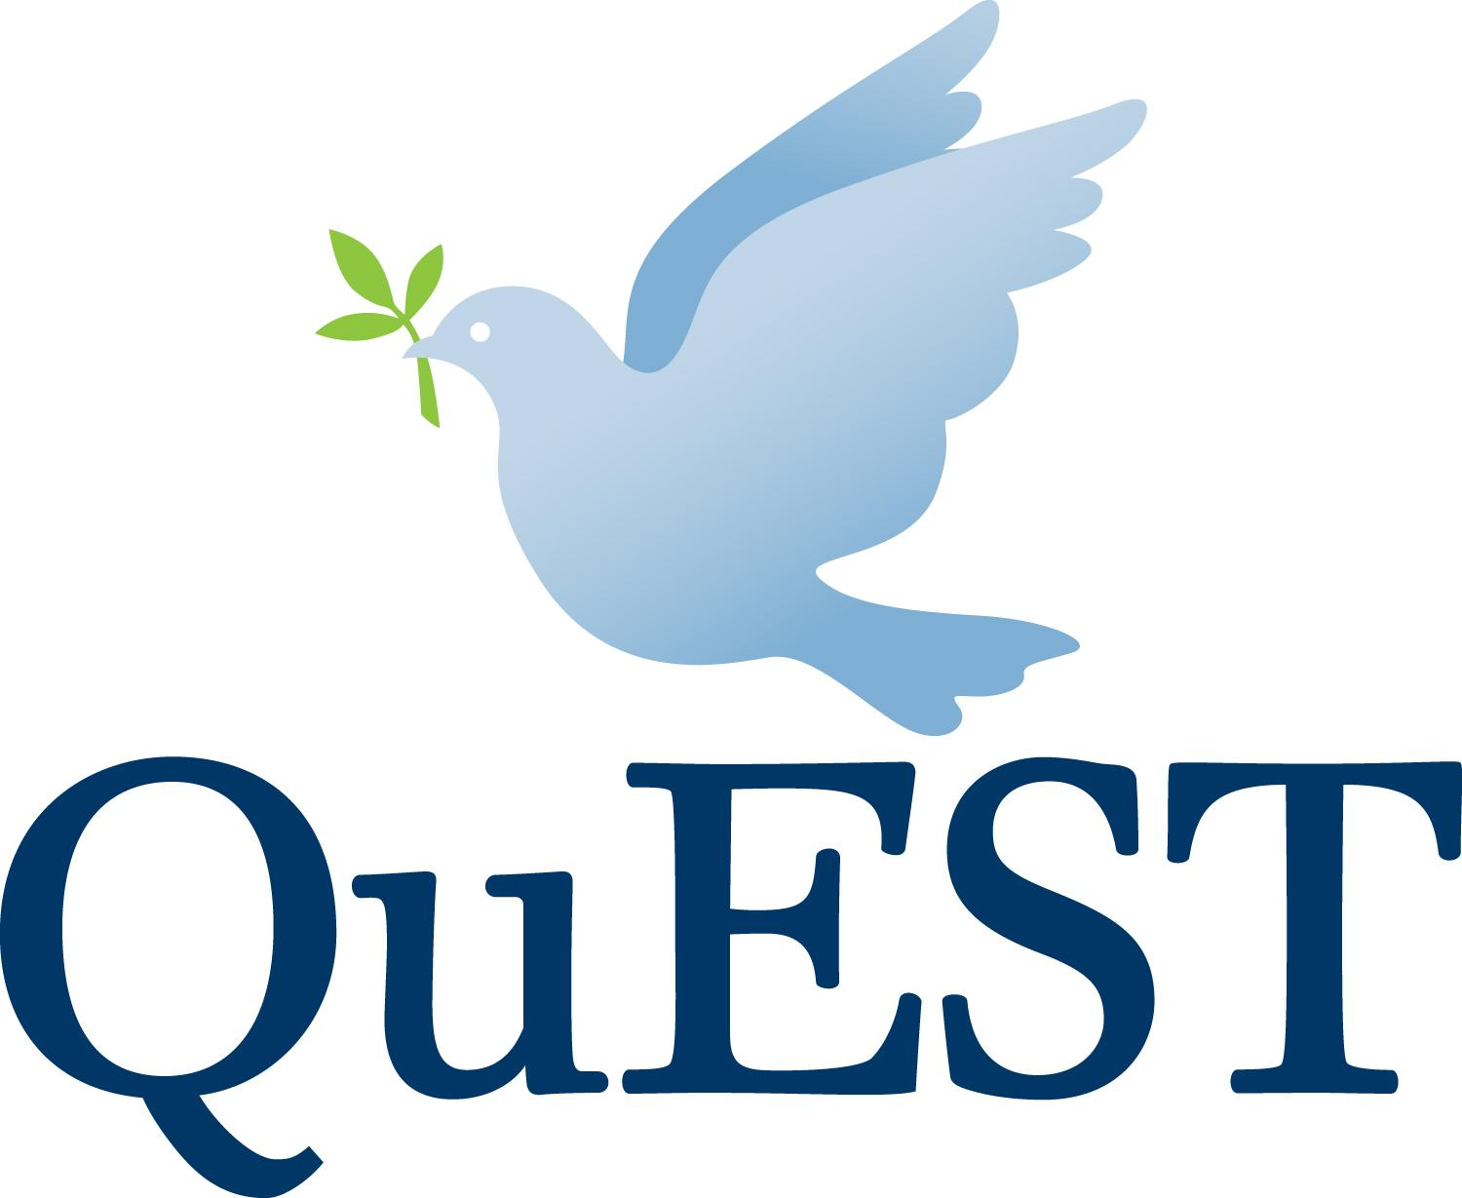
Application 2018

Thank you for applying to the QuEST program. This application will be reviewed by members of the Admissions Committee, which consists of two members of the QuEST Committee (Board), two current QuEST Fellows, and the QuEST Program Director. The Admissions Committee will first select applicants for phone interviews, then select ten to twelve finalists who will be interviewed by the service sites. Your resume and responses to the Interests and Experience section will be sent to sites at that time; Community Life answers will be read by the Admissions Committee only. A matching process, based upon service sites’ selections and applicant preferences, will determine final placement in the program.

A complete application includes this cover page; answers to the Community Life questions (two pages) and Interests and Experience questions (one page, separate documents please); list of three references; letter of recommendation from one of these references; and a current resume. Application deadline is March 15, 2018. After March 15, applications may be accepted on a rolling basis. Send completed applications and any questions to Promise Welkin Partner, QuEST Program Director: director@quest-seattle.org

Name: |  | Date of birth:
Gender Pronouns: |  | How did you learn about QuEST?
Current address:

Phone: |  | Email:
Permanent address:

Person to notify in case of emergency: |  | Phone:  Relationship:
Education: List post-secondary schools attended, beginning with most recent. (A college degree is required for most, but not all, placements.)

Answer the following questions in no more than three pages total. This is an open invitation so we can get to know you; feel free to be creative! Please submit the two sections as separate documents because the Interests and Experience questions will be sent on to potential service sites.

Community Life

- Why are you seeking service with QuEST? How does QuEST fit into your core beliefs and your long-term goals?

- Describe past experiences living and working in community. What have you learned about yourself, and what do you expect from your fellow community members?
- QuEST Fellows share one food budget and are encouraged to share meals. What is your philosophy around food? What compromises are you willing to make around food?
- Is there anything we should know about you so that we can ensure the community supports your experience in this program?
- QuEST is committed to Quaker testimonies of peace, simplicity, truthfulness, and equality. Describe the role these values play in your life. Why are you choosing a year of simple living?
- We seek Fellows from all walks of life. How do you see yourself living in community with people of different sexual orientations, gender identities, races, classes, and religions?
Interests and Experience

- What are you looking for in a service site? What would you like to learn?
- Please highlight the skills and experiences you would bring to this program. Which ones would you most like to use in your service site?
- What do you feel are your strengths and weaknesses as a candidate?

- How have you faced and overcome major challenges or difficulties in your life?

Attach a current resume.

References

Please list three references with their names, contact information, and relationship to you. Include at least one personal and one professional reference. Ask one of these references to write a letter of recommendation on your behalf. Letters should include the nature and length of your relationship and comment on your emotional strengths, your motivation and initiative, your skill in interpersonal relationships, your strengths and weaknesses, and your ability to work independently. References may send letters directly to director@quest-seattle.org.

